Project Design Phase-II
Data Flow Diagram & User Stories

Date | 18 February 2026
Team ID | LTVIP2026TMIDS53168
Project Name | Trans Lingua: AI-Powered Multi-Language Translator
Maximum Marks | 4 Marks

Data Flow Diagrams:
"In this project, data flows start at Process 1.1, where user input is cleaned. If a connection is detected, the flow moves to Process 1.2 for
high-fidelity AI translation via Gemini. If no connection exists, the flow is redirected to D2 (Local Store). Finally, Process 1.4 formats the output for the user, ensuring the data cycle is complete, accurate, and low-latency ."
Example: (Simplified)
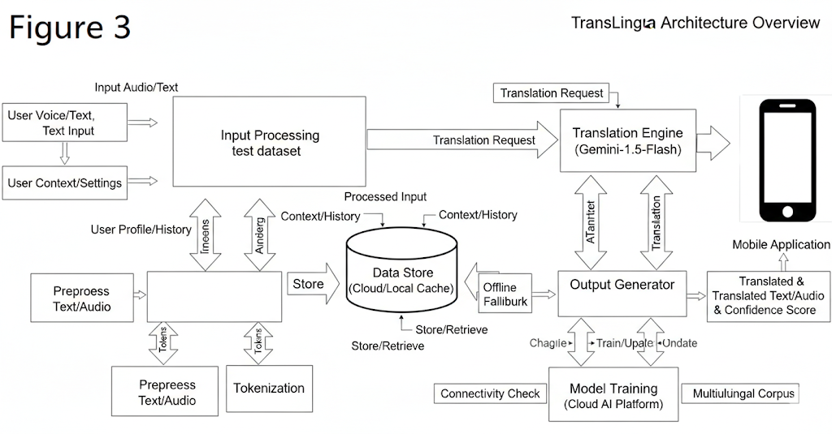

User Stories
Use the below template to list all the user stories for the product.

User Type | Functional Requiremen  t (Epic) | User Story Number | User Story / Task | Acceptance criteria | Priority | Release
Customer (Mobile user) | Registration | USN-1 | As a user, I can register for the application by entering my email, password, and confirming my password. | I can access my personalized dashboard and saved settings. | High | Sprint-1
 |  | USN-2 | As a user, I will receive a confirmation email once I have registered. | I can click the link in the email to verify my account. | High | Sprint-1
 |  | USN-3 | As a user, I can register for the application through Facebook for quick access | I can successfully log in using my Facebook credentials. | Low | Sprint-1
 |  | USN-4 | As a user, I can register for the application through Gmail. | I can sync my translation history with my Google account. | Medium | Sprint-2
 | Login | USN-5 | As a user, I can log into the application by entering my email & password. | I am taken to the translation interface if credentials are correct. | High | Sprint-2
 | Dashboard | USN-6 | As a user, I can input text or voice to be translated into another language. | see the translated text and hear the correctpronunciation. | Medium | Sprint-2
 |  | USN-7 | As a user, I can view my history of previous translation | I can see a scrollable list of my past 50 translation records. | Medium | Sprint-3
 |  | USN-8 | As a user, I can download offline language packs. | I can translate text correctly even when my device has no internet. | Medium | Sprint-3
 |  | USN-9 | As an admin, I can monitor app usage and manage active users. | I can see a dashboard showing total active users and API calls. | Medium
Customer (Web user) | Monitoring | USN-10 | As an admin, I can update the translation model version (Gemini-1.5) | I can deploy model updates without disrupting user service. | High | Sprint-4
Customer Care Executive | Manage Users | USN-11 | As a user, I get suggestions/tips based on detected disease | I see treatment or care tips shown on-screen | High | Sprint-4
Administrator | Model  Managemen  t | USN-12 | As a user, I get cultural tips or grammar suggestions for my translations | I see helpful pop-ups explaining the nuance of certain phrases | High | Sprint-4

